Year 1 Home Learning Activity Pack 6 – 29th May 2020

Dear Year 1 Families,
Welcome to ‘summer 2’ and Home Learning Activity Pack 6! Our new topic for this half term is ‘All Things Bright and Beautiful’. The focus of this topic is learning about different types of animals that live around the world, as well as exploring how we can use, enjoy and look after our own local environment carefully.
Of course, I am looking forward to seeing some of you in school next week. However, I will be continuing to provide a new Home Learning Activity Pack once every two weeks to support everyone’s on-going ‘home learning’ time.
As my role is now changing back to teaching in school, each pack will be quite a lot shorter, going forward. I hope that you will still find the ideas in the packs helpful and that you will be able to supplement them with learning from other sources such as the 'BBC Bitesize Daily' and 'Oak National Academy' websites. If you have any questions or need ideas about something in particular, please do ask!

Online Learning Resources
Here is a list of useful website addresses which are referred to in this, and previous, packs:
BBC Bitesize Daily Lessons - https://www.bbc.co.uk/bitesize/tags/zjpqqp3/year-1-lessons/1
Oak National Academy - https://www.thenational.academy/
White Rose Maths - https://whiterosemaths.com/homelearning/year-1/
Phonics Play - new.phonicsplay.co.uk
Phonics Play Comics - phonicsplaycomics.co.uk
BBC Super Movers - https://www.bbc.co.uk/teach/supermovers/ks1-collection/zbr4scw
BBC Bitesize Primary Games - https://www.bbc.co.uk/bitesize/collections/primary-games/1

As before, you can find all of the new resource files that are mentioned in this pack on the Year 1 section of our school website. Go to https://www.jys.org.uk/website, click on the ‘Classes’ tab and scroll down to Year 1. I am also continuing to post new additions on the Year 1 page of our Virtual Learning Environment (VLE), so keep checking that now and again too!
Please do keep in touch. My email address is: sarah.peart@jys.org.uk.
With very best wishes to you all,
Mrs Neville
Suggested Daily Timetable

Subject | Details | Approximate timing
Phonics | Use the ‘Phonics Play’ website to revise different sounds each day!  See Pack 2 for all the details. | 15 minutes
Reading | Apply your phonics skills and read a longer passage or story. Discuss what you’re reading with someone at home.  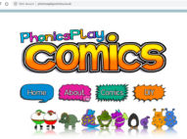  Use ‘Phonics Play’ Comics if you want to read a short text. See Pack 2 for all the details. | 15 minutes
Handwriting | Practise forming letters from a ‘chunk’ of the alphabet (c. 5 letters a day); practise joining different letters to each other.  See the ‘Cursive Letter Formation Handwriting Sheet with Rhymes’ given out with Pack 1. | 10-15 minutes
Writing | Try and write a few sentences every day.  You could write a diary, a joke, favourite facts about something you have learned, a set of instructions or part of a story - the choice is yours! | 20–30 minutes
Maths | Do the ‘White Rose’ and ‘BBC Bitesize Daily’ maths lessons.  Keep practising those key ‘Bronze Award’ mental maths skills.  Use ‘Sumdog’ and ‘TT Rockstars’ websites. | 20-30 minutes
Science and ‘Other’ subjects | Try and choose one ‘other’ subject to learn something about each day. Use the activities in this pack or watch a lesson from one of the websites mentioned (BBC or Oak Academy). | 30 minutes

In addition to the ‘academic’ learning covered in the timetable above, do keep making plenty of time for the following types of activities every day – they are just as important!
- art / creative craft / music / Lego building / imaginative play / cooking;
- ‘keep fit’ and ‘active’ activities such as walks, bike rides, Joe Wicks’ P.E. sessions and Cosmic Kids Yoga sessions;
- ‘down’ time just to relax and be quiet.

Literacy
Remember, it really doesn’t matter what your child writes about, as long as they keep writing! Even writing just a sentence or two each day will help them to maintain their skills. Remember to use the ‘Year 1 Phonics Mat’ to help them sound out and write their spellings phonetically.
They could write a short diary entry each day; write labels for something that they are making (e.g. a play shop or museum); make a joke book that they add to over time; write down their favourite facts about something they have learned; write a set of instructions or a conclusion for a science experiment that they have carried out; write a letter to a family member or friend; retell a favourite story in writing . . . the list goes on!

‘Sidney Spider – A Tale of Friendship’ unit of work
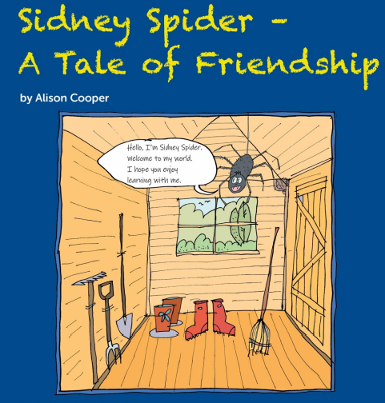
Please look at the attached document called ‘Literacy – Sidney Spider – A Tale of Friendship’. This is a unit of work written especially for Year 1, based on the story of ‘Sidney the Spider’. You can also listen to the story being read, by clicking on the following link:
https://soundcloud.com/talkforwriting/sidney/s-cFsSqUMech3

Enjoy sharing the story together and then complete the activities mentioned in the pack, over the next two weeks.

Maths – Daily Lessons
Please continue to use the White Rose Maths Hub and BBC Bitesize Daily websites for your daily maths lessons:
https://whiterosemaths.com/homelearning/year-1/
https://www.bbc.co.uk/bitesize/tags/zjpqqp3/year-1-lessons/1
Remember that you need to visit the school website to access the worksheets that accompany each daily White Rose lesson. Please do let me know if you have any problems with this.

In school, our maths lessons will focus on securing our strategies for adding, subtracting, multiplying and dividing. We will revise these skills and practise applying them in a range of fun ‘problem solving’ and ‘investigative’ contexts.

Maths – TT Rockstars
As you may have noticed, the ‘teacher set’ areas of TT Rockstars is currently set to focus on multiplication and division questions from the 2x, 5x and 10x tables. However, I know that some of you are now really confident with these multiplication tables and are enjoying the challenge of learning some of the others. If you would like me to ‘change’ or ‘add in’ different multiplication tables on TT Rockstars for you to practise, please just email me and I can organise this for you.
For example, if you’ve been practising your 3x table, you might like to have two weeks when only questions from this multiplication table appear in the ‘teacher set’ areas of TT Rockstars for you. After that, you might like the 3x table questions to be mixed with 2x table questions and then mixed with 2x, 5x and 10x table questions.

Science /Geography
Continue learning about ‘Plants’ and ‘Seasonal Changes’, using the ideas given in Pack 2. Also, see the ‘Oak National Academy’ lessons outlined in the section below.

Science
‘Animals, including Humans’ topic
Learning objectives for the next two weeks:
- identify and name a variety of common animals including fish, amphibians, reptiles, birds and mammals;
- describe and compare the structure of a variety of common animals (fish, amphibians, reptiles, birds and mammals, including pets).

Lesson 1 – Introduction to Animal Classification
Watch the twinkl ‘Quick Facts: Animal Classes’ video:
https://www.twinkl.co.uk/go/resource/tgv2-sc-31-animal-classes-30-second-video

Look at the ‘Science – Grouping Animals’ PowerPoint presentation and answer the questions as you go through it.

Lesson 2 – Finding out about the characteristics of different animal groups
Look at the ‘Science – Animal Group Posters’ document and find out more about the characteristics of different animal groups.
Focus on the following animal groups in particular and then read about the other groups if you want to!
- Mammals
- Amphibians
- Reptiles
- Fish
- Birds
- Insects
As you read the posters, think about the similarities in, and differences between, the different groups. For example, which are warm blooded and which are cold blooded? Where does each group of animals tend to live?

What information can you find out about vertebrates and invertebrates from the posters?

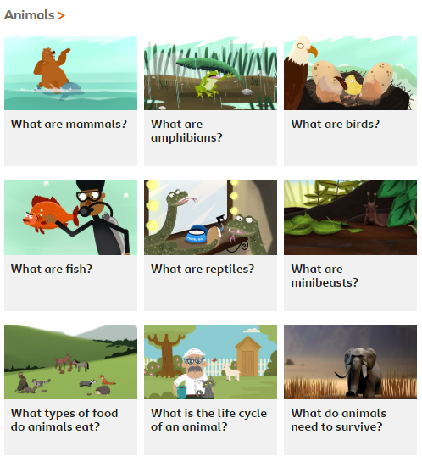
Lesson 3 onwards!
For each ‘lesson’ going forwards, choose one animal group to research in more detail.
You might like to get started by having a look at the ‘KS1 Science – Animals’ section of the BBC Bitesize website:
https://www.bbc.co.uk/bitesize/topics/z6882hv

As well as these ‘learner guides’, there are also 46 ‘class clip’ videos that you might like to watch! In particular, have a look at these ones:
- Amazing Amphibians;
- Fabulous Fish;
- Magnificent Minibeasts;
- Marvellous Mammals;
- Remarkable Reptiles.

When you have researched the animal group, decide how you will present what you have learned. Will you write a ‘Did you know?’ fact file, draw a labelled diagram or give a presentation to someone at home about the most interesting facts that you have found out? These are just a few ideas – the choice is yours!

‘BBC Bitesize Daily’ Year 1 Science Lessons related to our topics:
13th May – Science – Animal Groups
6th May – Science - Basic Parts of a Plant

Oak National Academy Year 1 Lessons:
It is worth having a look at the Year 1 ‘Science’ lessons, which link nicely to units of work that we have already done. By the end of the summer term, the following lessons will have been covered on the Oak National Academy website:

Unit 1: Seasons and Change
Week 1 - What do we know about the weather?
Week 2 – How does weather change across the seasons?
Week 3 – What kind of weather can you observe?
Week 4 – Identifying rainfall measurements from different seasons.
Week 5 – Understanding hibernation.
Week 6 – Observing and recording wind direction.

Unit 2: Sound
Week 7 – What are the five senses?
Week 8 – What is sound?
Week 9 – How do we hear?
Week 10 – How can we describe the volume of a sound?
Week 11 – How can we describe the pitch of a sound?
Week 12 – How can we make and describe different sounds?

Boredom Buster Activities
If you have a spare few minutes, why not have a go at some of the activities in the attached ‘Boredom Buster Activities’ document? Have fun!

