Baby Egg Word Problems



sweets

Baby had 4 sweets. He ate 3 sweets. How many sweets did Baby Egg have left?

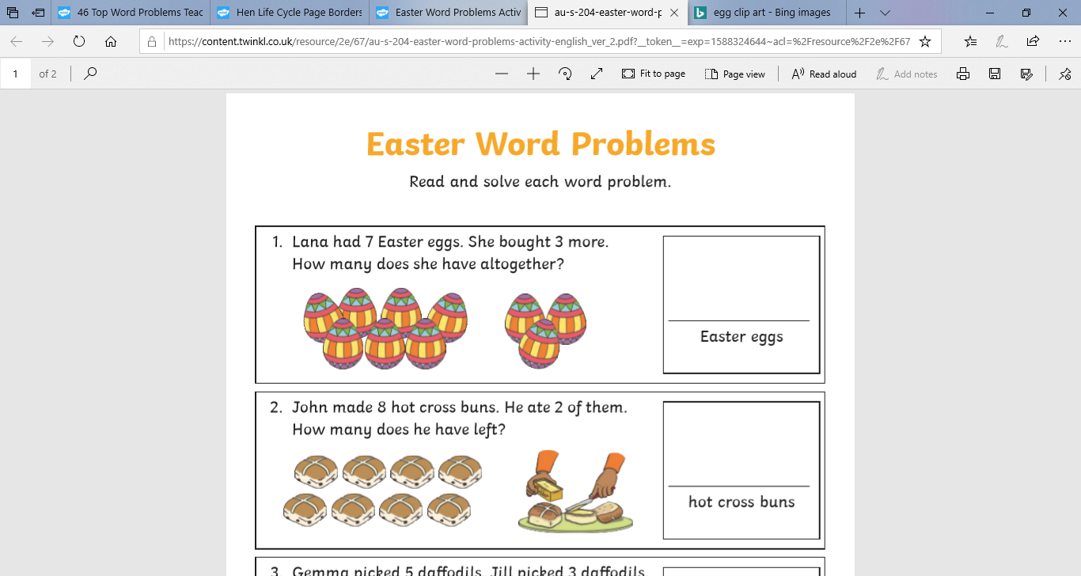

eggs

Baby Egg decorated 7 eggs. His friend decorated 3 more. How many eggs did they decorate altogether?

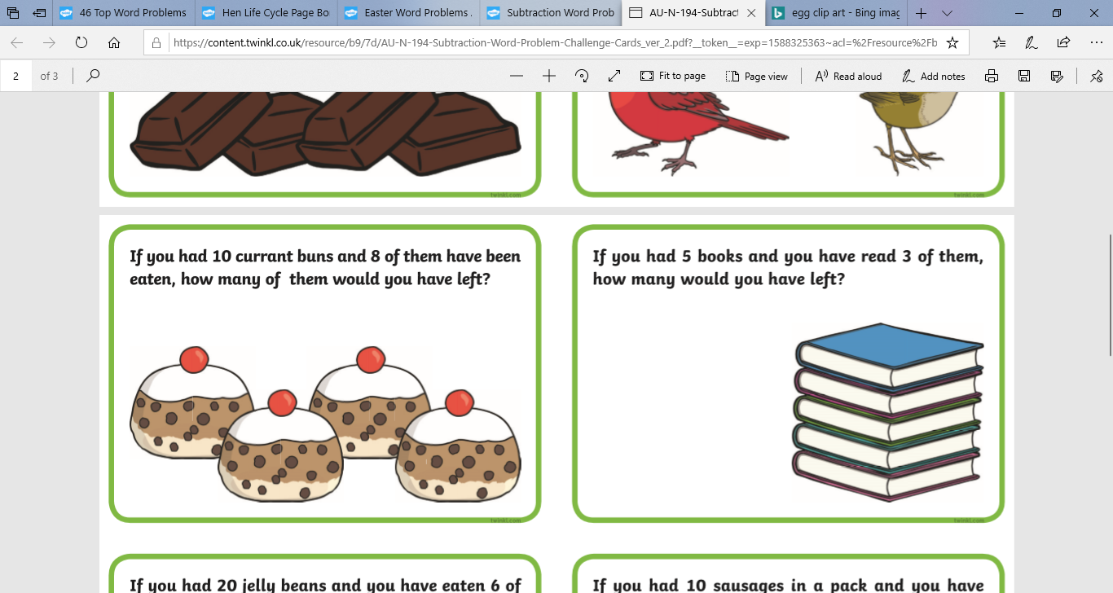

Challenge: Can you write these as number sentences?

cakes

There were 4 cakes in the shop. Baby Egg only wanted half the amount of cakes. How many cakes did Baby Egg buy?

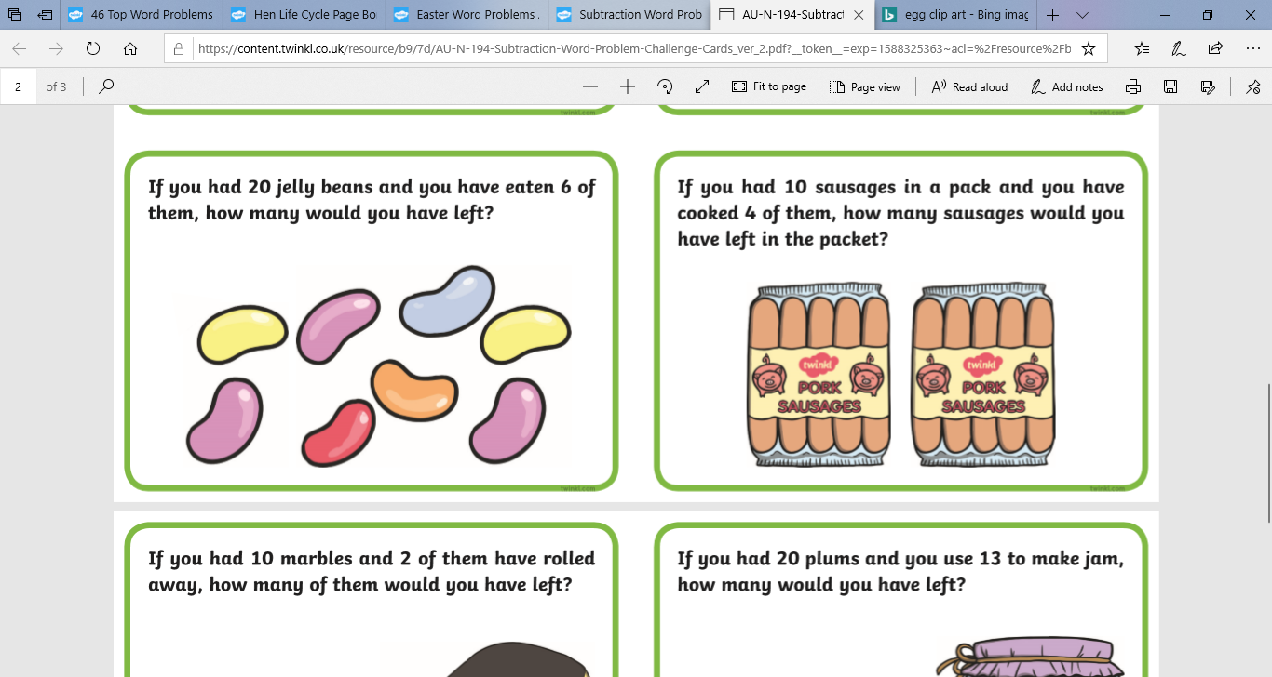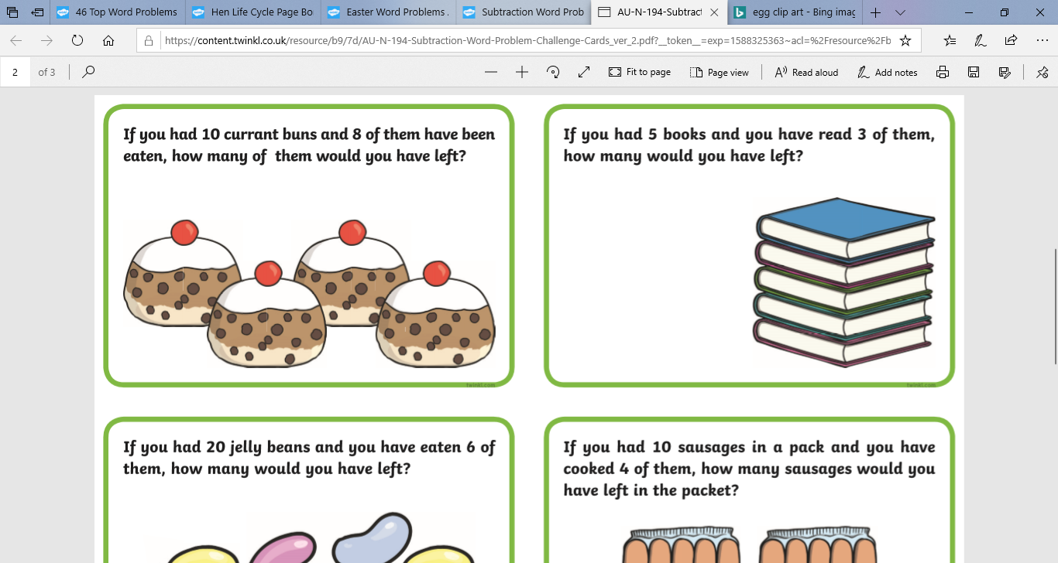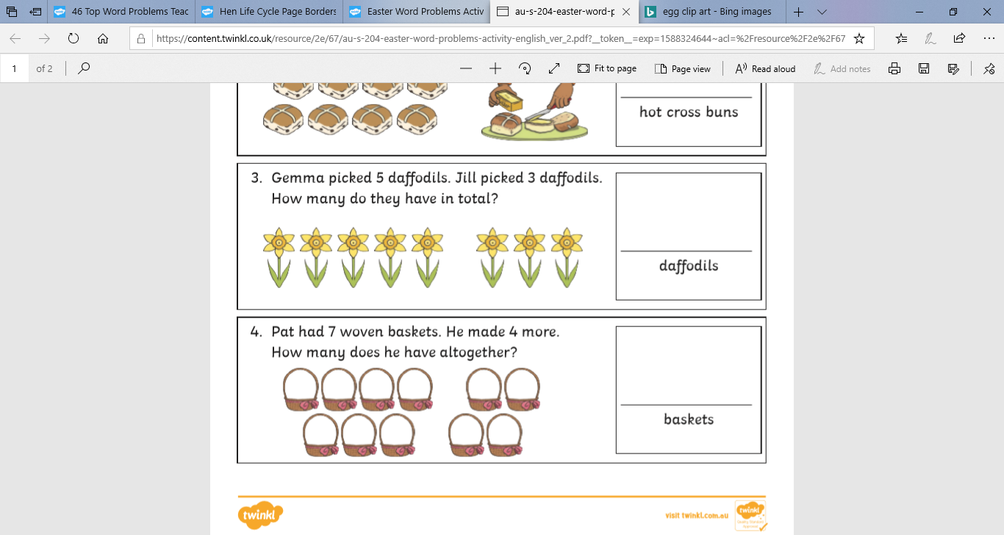

Challenge: Can you write these as number sentences?

Baby Egg had 8 jelly beans. Baby Egg didn’t eat them all, he ate 1 less. How many jelly beans did baby Egg eat?

jelly beans

books

Grandad Egg challenged Baby Egg to read 5 books. Baby Egg read double the amount. How many books did Baby Egg read in total?

Baby Egg picked 5 daffodils. He then picked 1 more. How many daffodils did he have altogether?

daffodils