French home learning - Y5 June

Bonjour!
Do you remember the books about Berthe the witch and her cat? There’s a new one, about Berthe not being able to travel at the moment, just like the rest of us, and how she uses magic to travel around the world. Here it is!
https://youtu.be/NRC6fYGHoME
It starts with a song:
Berthe est une sorciere. Elle habite une vieille maison.
Elle a un petit chat, qui aime la glace et pas le poisson.
Viens, viens la voir!
Viens lire son histoire.

Read and listen to the story once through and see how much you can understand. I bet you can work a LOT out! If you need to check any vocabulary, you can find it on this page: https://bonjourberthe.co.uk/berthe-voyage-online-story/ .
You might find it helpful to write down the words you don’t know first, then add the French translation. Then you can stick it into your vocab book eventually. You can stop the film any time to write down or look up words.
On the next page is a wordsearch about the story for you to try. There’s a quiz and other activities on this web page: https://bonjourberthe.co.uk/berthe-voyage-online-story/ .

Let me know how you get on!

I’ve also posted a French cookery book, with English alongside and clips to show you any tricky things. Do send me pictures of anything you make!
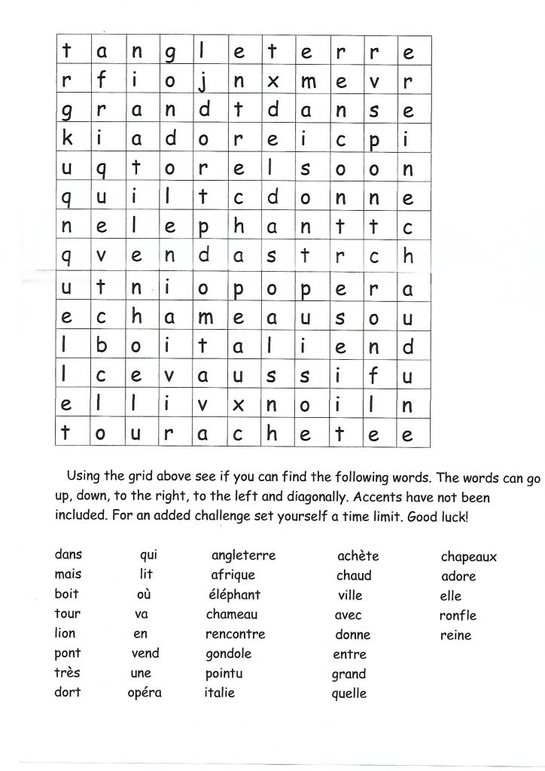
I hope you enjoy this new French work. If you’re stuck on anything or want to ask me a question, email me on rachel.ritchie@jys.org.uk and I’ll get back to you.
À bientôt! (that means ‘See you soon!’)
Madame Ritchie

