The benefits of using play dough for young children are wonderful and the play possibilities are endless!

BEST EVER NO-COOK PLAY DOUGH RECIPE
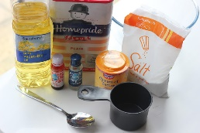
You need:
- 2 cups plain flour (all purpose)
- 2 tablespoons vegetable oil (baby oil and coconut oil work too)
- 1/2 cup salt
- 2 tablespoons cream of tartar
- 1 to 1.5 cups boiling water (adding in increments until it feels just right)
- gel food colouring (optional)
- few drops glycerine (secret ingredient for stretch and shine- but definitely not necessary.
Method:
- Mix the flour, salt, cream of tartar and oil in a large mixing bowl
- Add food colouring TO the boiling water then into the dry ingredients
- Stir continuously until it becomes a sticky, combined dough
- Add the glycerine (optional)
- Allow it to cool down then take it out of the bowl and knead it vigorously for a couple of minutes until all of the stickiness has gone. * This is the most important part of the process, so keep at it until it’s the perfect consistency!*
- If it remains a little sticky then add a touch more flour until just right
Voila!
You can store this play dough in an air tight container.
Adding pipe cleaners, feathers, beads, buttons or even dried pasta can ignite imagination!

