Reading Activities

Choose one of these activities to go alongside your reading book each day and record in your reading comments book.

In a nutshell...  Write a ten word summary of the pages (or book!) you have just read.  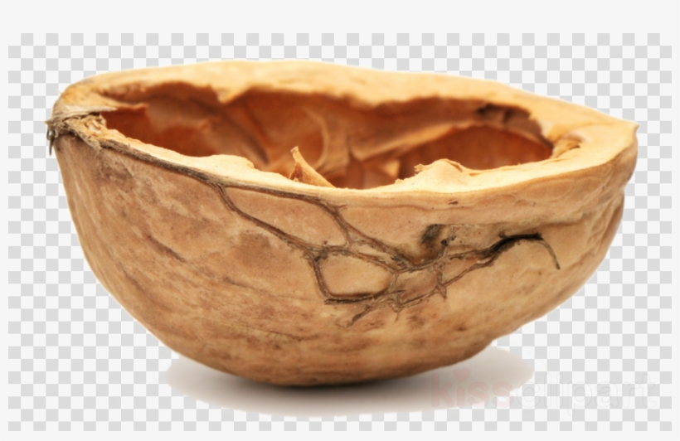 | Dear diary...  In first person as the main character, write a diary entry about the main event.  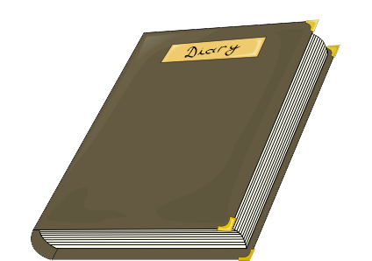 | Sam-I-Am...  How are you similar to the character in the book? How are you different? Create a table.  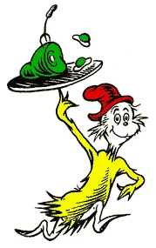 | Word Detective...  Find 10 words that you are unsure of the meaning and, using the sentence, find the definition.
Incredible Illustration...  Choose the favourite page you’ve read today and create an illustration for it. | Perfect Prediction...  If you’re starting a new book, before you begin write three predictions you can make from the front cover!  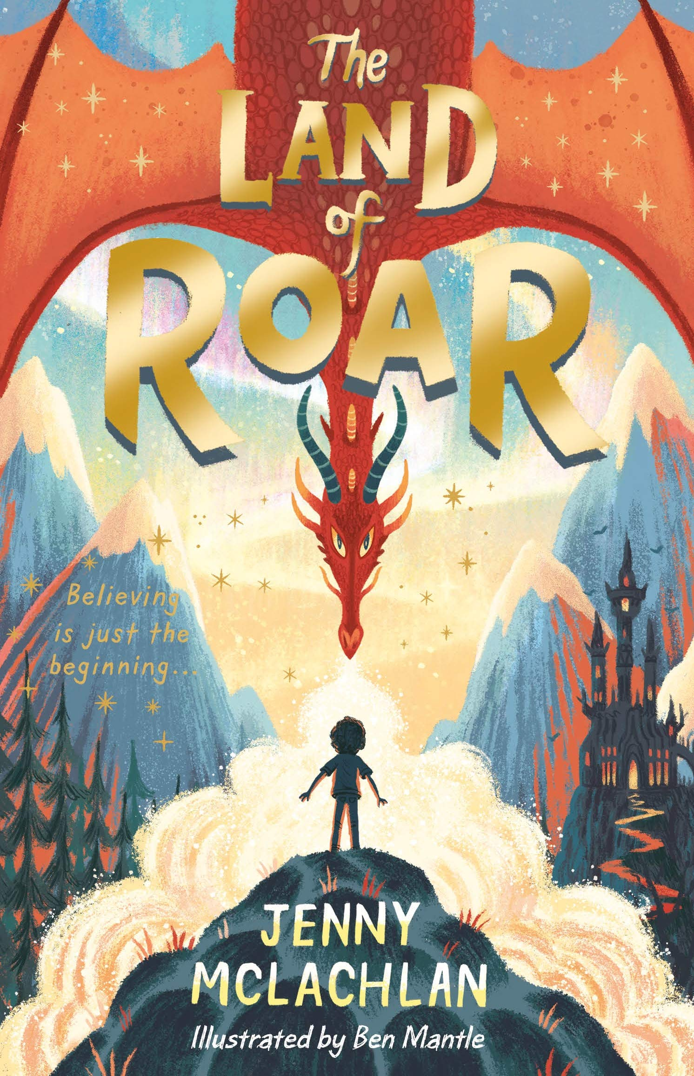 | Front Cover  When you finish the book can you create a front cover? Remember - don’t give the story away! | Act it out...  Act out a scene from the book - can someone guess what’s happening?
I say...  Draw a speech bubble - what was a character thinking during the events of the page? | Vocabulary Ninja...  Find 5 words which add atmosphere to the book. Use them in your own sentence. | 20 Questions…  Write down 10 questions you’d want to ask the characters from the book. | Decisions, decisions...  Choose a decision the character has made and write reasons ‘for’ and ‘against’.
Hear Hear...  Tell someone the favourite part of your book and why. | Time to...  Create a timeline for your book with 5 main events on.  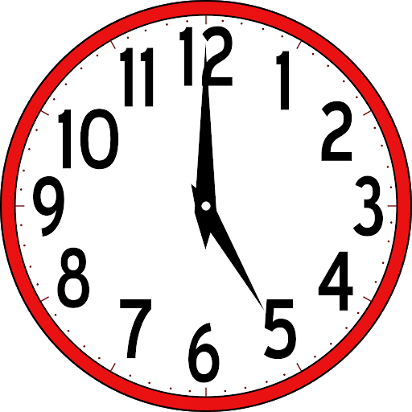 | In the news...  Write a newspaper report of an event from your book. | Valiant values...  How did a character show our school values?

