My estimate is ________ cubes long.  The arm is ________ cubes long. | My estimate is ________ cubes long.  The head is ________ cubes long.
My estimate is ________ cubes long.  The leg is ________ cubes long. | My estimate is ________ cubes long.  The tummy is ________ cubes long.

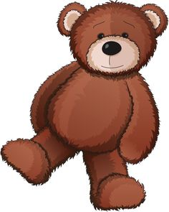  My estimate is ________ cubes tall.  The teddy is ________ cubes tall. | My estimate is ________ cubes tall.  The teddy is ________ cubes tall.
My estimate is ________ cubes tall.  The teddy is ________ cubes tall. | My estimate is ________ cubes tall.  The teddy is ________ cubes tall.

